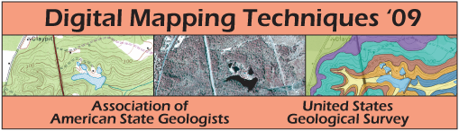

ACCOMMODATIONS
A block of rooms is reserved at:
Clarion Hotel Morgan (~ 0.65 mi. from WVU Downtown Campus)
127 High Street
Morgantown, WV 26505-5412
Telephone (304) 292-8200
Fax (888) 241-7944
Reservations (877) 424-6423

Rate: $69 Single/Double (Reservations must be made by April 9, 2009)
Rooms are reserved under Digital Mapping Techniques ’09

Other Hotels located in the Morgantown area:
Euro-Suites Hotel (~ 2.25 mi. from WVU Downtown Campus)
501 Chestnut Ridge Road
Morgantown, WV 26505
(800) 678-4837

Hampton Inn Morgantown (~ 1.9 mi. from WVU Downtown Campus)
1053 Van Voorhis Rd.
Morgantown, WV 26505
(304) 599-1200

Waterfront Place Hotel (~ 1.0 mi. from WVU Downtown Campus)
Two Waterfront Place
Morgantown, WV 26501-5958
(866) 782-9974

